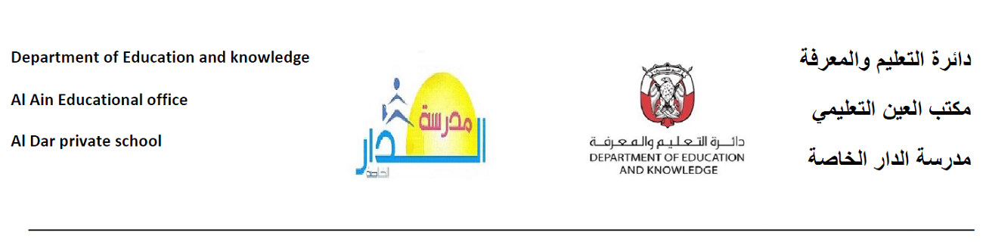
الاسم:......................... ورقة عمل الصف:الثامن

السؤال الأول : - اكتب موضوعاً عن الإنترنت موضحاً أضرار الإنترنت ، وفوائده ، وكيفية الإستخدام الأمثل للإنترنت .
................................................................................................................................................................................................................................................................................................................................................................................................................................................................................................................................................................................................................................................................................................................................................................................................................................................................................................................................................................................................................................................................................................................................................................................................................................................................................................................................................................................................................................................................................................................................................................................................................................

السؤال الثاني : - ما المقصود بالعزلة الإجتماعية ؟
..........................................................................................................................................................................................................................................................................................................................................................................................................................................................................................................................................................................
...............................................................................................................................................................................................................................................................................................................................................................................................................................................................................................................................................................................................................................................................................................................................................................................................................................................................................................................................................................................................................................................................................................................................................................................................................................................................................

